**Intro:**

**\*If you are Windows users, we highly recommend you follow** [**Moai Print Guide with Asura.**](https://docs.google.com/document/d/1YDDTXiwi00KFVIGMVTl7Ke_9gclbFdYEs6FMxEuQ6XM/edit?usp=sharing)

Moai takes Gcode as input for printing. Many steps are similar to FDM printing. However, there are considerations unique to SLA printing and ecosystem. This instruction covers how to print on Moai and how you can build a printing process that suits your need.

While Moai is a SLA printer, it uses standard Gcode as toolpath for its laser the same way FDM printer extruder moves based on Gcode and print layer by layer. Many ideas and considerations are the same. But there are significant difference as well

**Same:**

* A good first layer. This is as important as FDM. Moai is a bottom up SLA printer, meaning it prints the object upside down. A good adhesion means the object would not break off during the printing or fall down into vat:  
  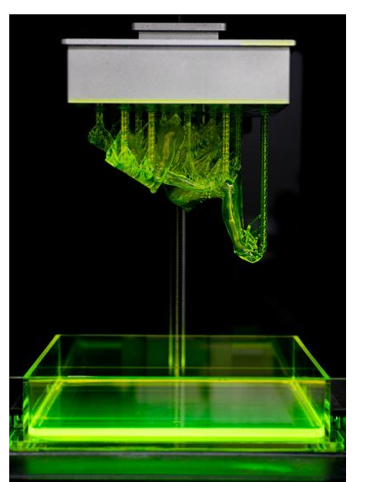

There are couple ways you can get a strong first layer with longer exposure time, stronger laser power and use of brim. You can also help the object to stay on platform by reducing object weight via hollowing. More on these points later.

* Support generation.

While Moai prints upside-down, it still has to deal with gravity and support is as important as ever. The shape and size of support are different but the idea is the same.

* Speed vs detail.

Like most SLA, Moai typically prints with a layer of 0.025mm to 0.1mm. The more detail, the longer it takes to print. 0.1mm is commonly used for prototyping while 0.05mm is most frequently used. 0.025mm are used for professional results. Anything lower than that can still be done but now the resin’s own error tolerance comes into play. Any desktop level printer talking about printing less than 0.015mm (15 microns) are not be realistic about the materials they used. For Moai printing, we recommend 50 microns and 100 microns for detail, and speed

**Difference**

* Upside down printing

Because Moai is a bottom up printer like Form1+ and Form2, you have to consider gravity that may pull down the object. This is only a concern when printing large object. The hollowing section deals with this. This also affects how prints are oriented and how you deal with overhang. In general, Moai can deal with overhang very close to 0 degree.

* Resin

Resin is significantly different than filament in many ways. Resin needs post-processing to fully cure it. Resin can also irritate skins so please see the safety section down below. And finally, because the object is immersed in the resin, if the object is hollow, there may be resin trapped inside. When you hollow an object, you should also consider drain holes. These are covered below

**Safety**

There are two potential safety hazards with laser SLA printers:

* Laser
* Resin
* Post Processing

**Laser**

Moai uses a 405nm 150mw UV laser. It is considered low powered laser but still can hurt human eyes if aimed directly at the focus length. Therefore, please wear goggle if you are going to be testing it with panels removed. Moai’s panels can block the harmful UV light so you will be ok if it is completely closed. Reflect UV lights are much weaker but still avoid looking at it over extended time.

**Resin**

Moai Resin, as well as almost all SLA printer resins can irritate skins if it comes in direct contact with the skin. Wear gloves when handling resins and holding not-fully cured objects. Wash with warm water and soap if resin comes in contact with your skin. If your eyes come in contact with resin, quickly wash with warm water only to remove as much as you can and seek professional help immediately. Resin safety has its own safety document in the folder

**Post-Processing**

High content 90%+ ethanol is recommended for Moai resin. IPA can be used as a substitute. Please wear glove when handling it to avoid directly exposure to skins and eyes or it may cause over-dryness. Please keep it away from flame.

Formlabs has a nice safety instruction that applies to Moai:

https://formlabs.com/support/printers/form-1/safety-first/

Before we gets into the detail, please know that

**DO NOT REMOVE RESIN VAT WITHOUT TAKING DOWN THE BUILD PLATFORM.**

**Forget doing that may result resin on the build platform drip into the system below, causing significant damage to galvo and short the boards.**

**Print Steps:**

This is a set of the common steps in sequence when printing on a SLA printer like Moai. Not all steps are necessary and you may skip 1 and 2 depending on the object.

1. **Orientation of the object.**
2. **Does the object need base?**
3. **Does object need hollow? Yes -> Meshmixer**

**Key factors: size and shape of the print. Need to think about drain holes. Object shorter than 8 cm (z-axis) usually is not a problem. It depends on the size of the base and support too.**

1. **Support generation? Yes -> Meshmixer**

**Key factors: overhangs and orientation. Moai resin has a 45 degree angle threshold**

1. **Print: Cura 2.6 Moai Edition**
2. What is the best orientation for the print?

This should be considered with base and support as well. The optimal orientation for an object is to have a high print success rate with least support. This means avoiding having difficult to print sections like islands (parts of object that have negative angles) or long horizontal feature. At the same, consider to have enough surface area to the plate so it can sticks well. This leads to the topic of base

1. Base

If you are printing an object that doesn’t have a flat surface on all side, it may need a base to improve print success. I almost always print with a base. Please refer to “Base” instruction

<https://drive.google.com/open?id=1S3Kru1g6sITmppF0Kl85T9vfNQzKC7nvrIKVAE0Ziys>

You need to decide on orientation before adding base

2. Hollowing

One of the key factors when printing on “Bottom-Up” SLA printer that does not exist on FDM is the weight of the object and the cost of resin.

The decision is as such:

Can the object to be too big and too heavy such that it may fall out of the platform and into the vat?

Is transparent resin used? Because it may show the internal support if the object is hollowed out

Save some resin?

How to decide:

If you are printing a solid block of object with little nuances, then it may be best to consider hollowing out. Example:

This object has some finely detailed parts but mostly big solid part. This would be a good candidate for hollowing.

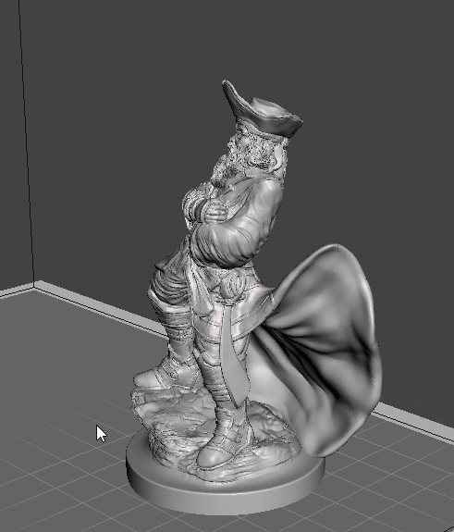

This ring is delicate and has a lot of fine feature. Hollowing is unnecessary here.

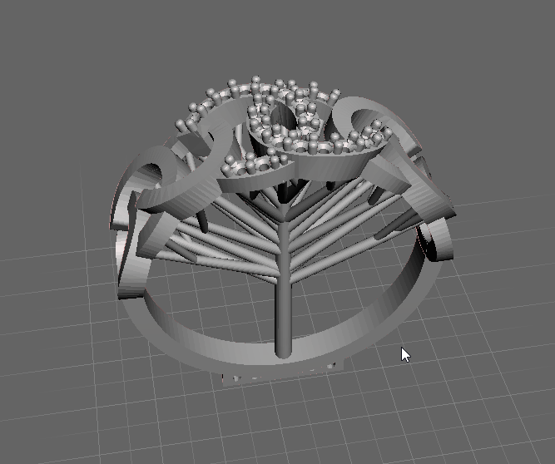

The way you hollow is use Meshmixer’s hollowing function.

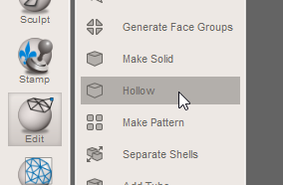

Full manual can be found here: <http://www.mmmanual.com/hollow/>

Basically, the offset distance is the wall thickness and you don’t want less than 1mm. And you would want to drill holes (it is part of the function).

Double click the spot where you feel drain hole is needed. It is recommended to have 2 drain holes per hollow section so resin would not be trapped. One drain hole should be at top part of the hollow section and the other on the side, ensure air can enter and resin can escape.

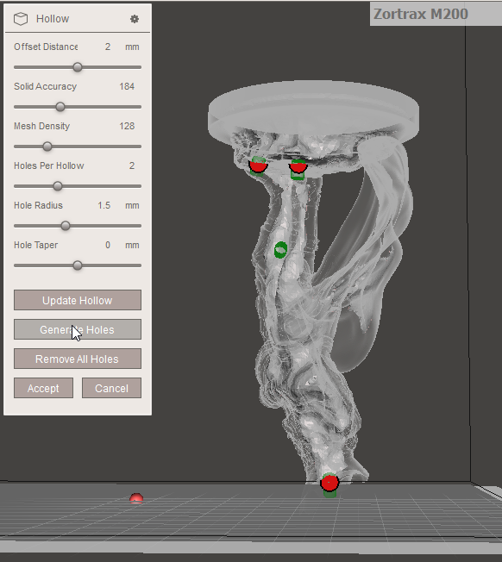

-

**3. Support generation (V2 updated, do not use Print Studio)**

Support generation is a key part of printing process. SLA and FDM printers are so different, they require different type of supports for overhangs. There are a lot less software for SLA than for FDM and we recommend 2 good ones we tested. Some models have pre-generated support then don’t create your own support and you can skip this part.

Meshmixer -

Meshmixer a tool for adding support

Before doing any work, first thing is to check for mesh errors.

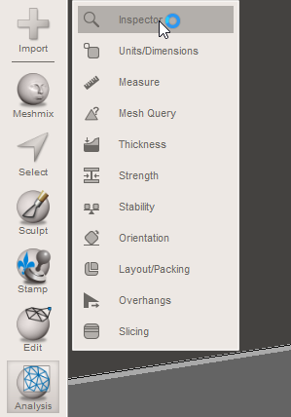

Auto-repair does it for me 99% of time.

Then depend on the object, you select what to do next.

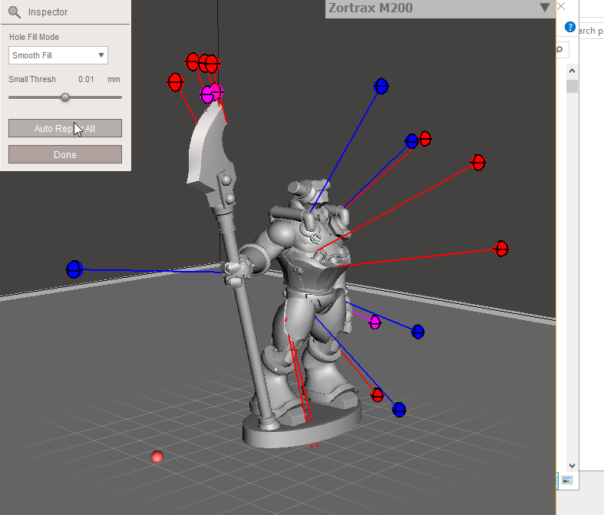

I go with smooth fill but flat fill works as well and is a little faster.

Base

If object has a pre-built base, that is usually the preferred way to print by the original designer. You don’t have to follow it but it is usually a good idea to do that. Refer to 1. Base section for an easy way to add base

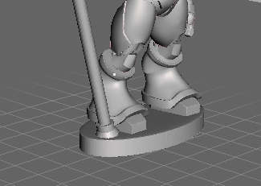

Orientation

If it doesn’t have a base or you want to test to see if there is a better angle, you can use orientation function in analysis

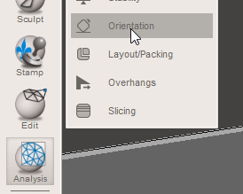

45 degree is what I use. You can go for less overhang if you want to play it safe. This number should match what you will use in the support. However, with bottom up printer, anything with overhang angle over 0 can be printed without support. This will be shown in the next section more. Orientation decision has a lot to do with if there is a base already, and minimize support vs print success

Support Generation

Use Overhang in Analysis.

Make sure it is i SLA/DLP printer mode if this is the first time you are using it.

**Angle Thresh is set to 5** (you could set it higher but it may add too much support)

Angle = 0

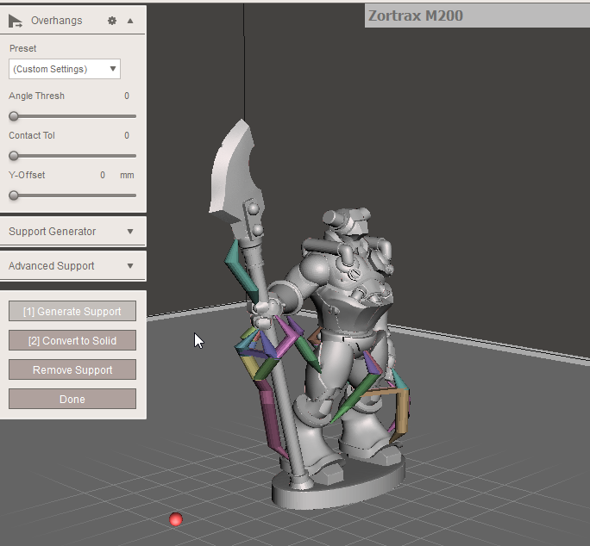

Angle 45

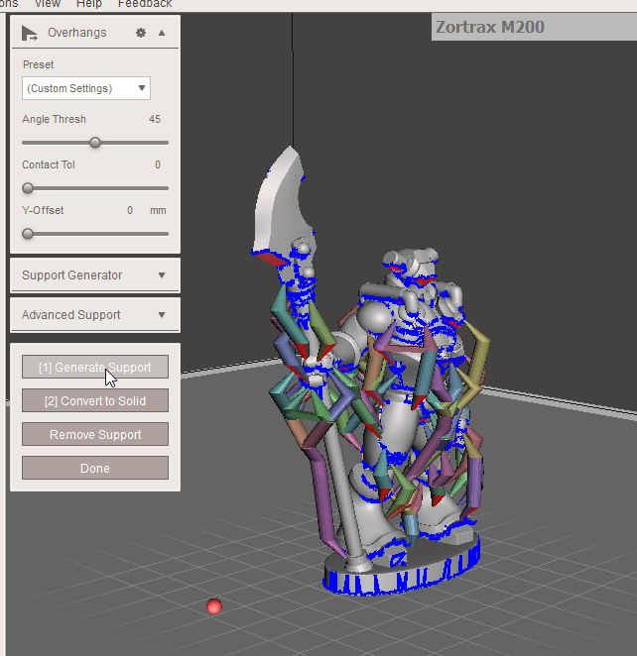

Y-Offset is how much it will raise the object up from platform. This is a SLA-specific function as first couple layers are affected by silicon in the vat.

This object has a base already so it does not need Y-offset so I set it to 0. As mentioned, I almost always print with base. With y-offset = 3, this is what it looks like:

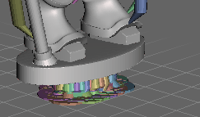

And you can click generate to get support. Click done and you can export

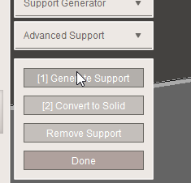

If you don’t like it, click remove support and change setting.

Then

Export to STL

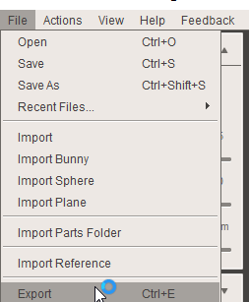

Some interesting settings to modify if needed:

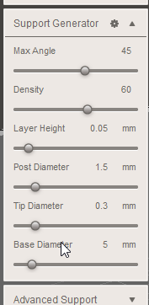

DON’T Change later height, it is broken.

Tip Diameter is for tip of support, larger means it has a better grip on the object.

Base Diameter is the support beam base, the larger means better grip on the support. I often bump it up to 8mm when I print without base so this will act like a base with a y-offset

-

-

**Slicing (V2 updated)**

We use Cura 2.6 for slicing and optimize it for Moai. It has Moai settings built in and we made custom Moai profiles for it.

The only part you need to adjust for printing in Cura after import presets are the print speed.

The print speed (movement of the extruder) in cura will be translate to the speed of laser spot movement. Essentially, the laser spot will move through the toolpath from slicing the same way a extruder would move in a FDM printer. To reduce exposure, you increase the speed (thus making reduce how long a laser spot stay in one spot) and vice versa for increase exposure.

Here, the standard exposure time (print speed) are in 85mm/s value

There are Travel speeds settings, thus have 300 mm/s value

And the initial layer print speed is 5 mm/s unless there is a good reason, do not change. And don’t change initial layer height either!

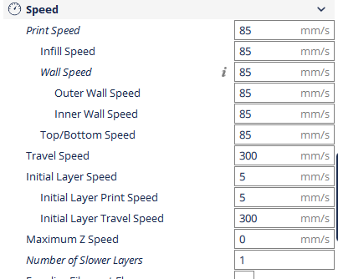

Please make sure support is off

And Brim is enabled with 20mm line count

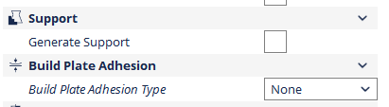

Recommended setting for included resin:

**Energy level set to 58% (from advanced setting on printer)**

**0.1mm Print speed is 85mm/s, first layer is 5 mm/s**

**0.05mm Print speed is 130mm/s, first layer is also 5mm/s**

**0.025mm Print speed is 200mm/s, first layer is 5 mm/s**

**Infill is 70% for most prints. 50% for large prints**

**The first layer of print is always 0.1mm regardless what layer height you are going with. This ensures strong 1st layer and constant 1st layer print speed**

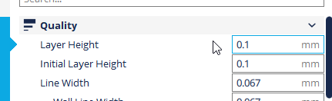

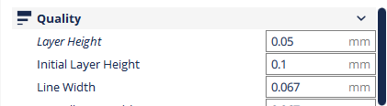

To print different heights, just select from the drop down menu

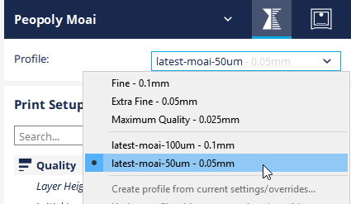

Click on

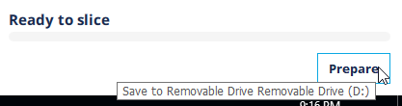

Wait for the slicing to be finished:

You can see the drain hole here.

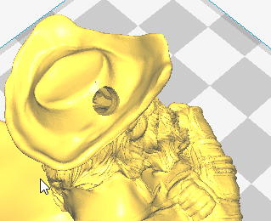

Save the gcode to SD card. Ignore the print time as laser moves much faster than extruder. It is often one sixth or even less time.

And make sure place the gcode in the gcode directory of the SD card (X:\gcode\)

File name should have less than 25 characters

And you are ready to print

-

**Positioning of the print**

Below is how print positions on Cura compares to its location when printed in Moai:

A->A and vice versa.

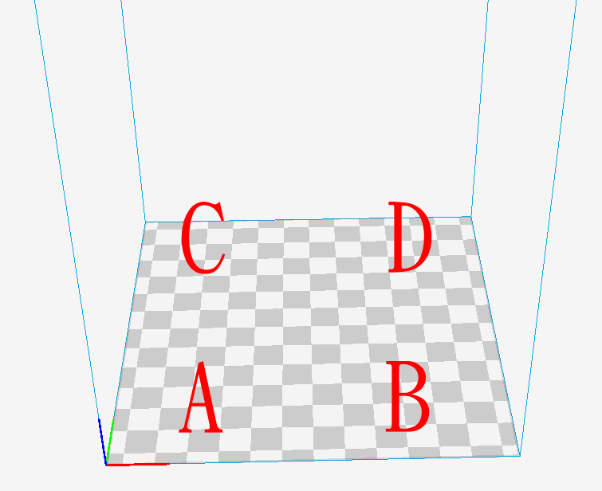

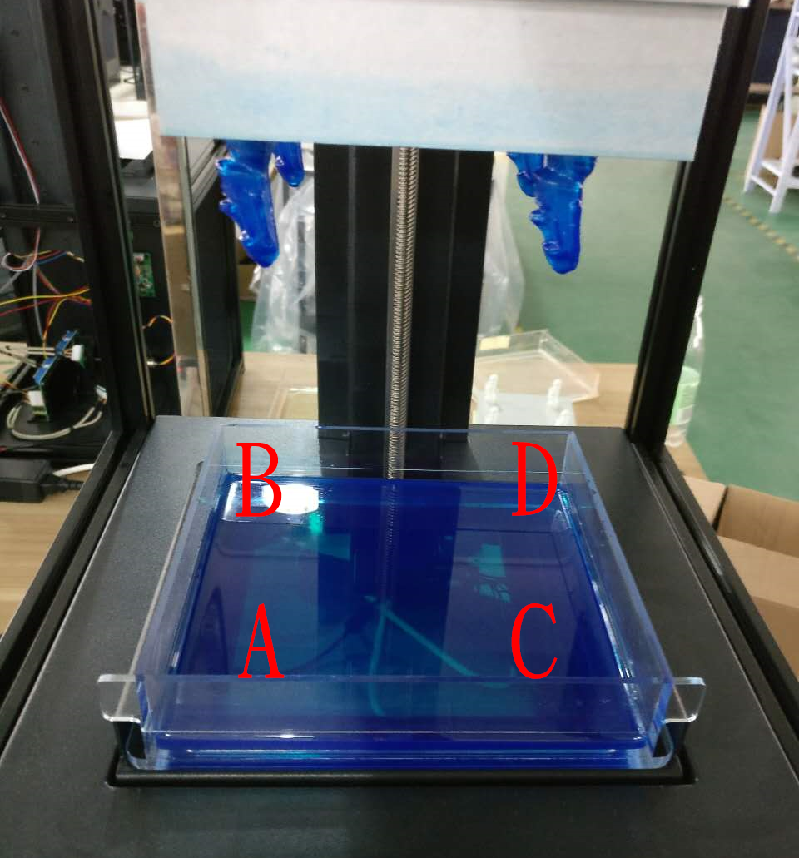

-

Extra notes on Gcode:

You could use other slicers but some of the display feature may not show correctly and has unneeded starting gcode.

Basically, Moai interpret only a few gcode command:

G0 G1 for movement. F for speed and E for exposure

Home command works as well. Because there is no filament, there is no need to extrude a little bit before printing, please remove that code if you are using your own slicer

**Notes on Exposure**

a bit about laser power, exposure and resin as you guys starting to print and experiment:

1. the more transparent and lighter the color, the less energy they absorb, thus needed higher exposure. keeping laser light constant black/blue can go up to 100 while clear may be around 75mm with laser power holding constant

2. higher exposure can be achieved by higher laser power and/or slower laser speed

3. the photosensitive chemical reaction does not correlate linearly with exposure amount. this means you cannot cut the laser energy by simply half and cut the speed down by half and expect the same results. once laser power drops to a certain level, it will not cure fast enough to have a good success rate

4 The best approach I found so far is to find the minimal laser energy that will solidify with a print speed of 80mm/s for layer height at 0.1mm. and then fine tune by increase / decrease speed. the lower laser power you can get away to do successful print, the better surface finish as laser spot would be smaller

**Post processing**

This is the least fun part of any kind of 3D printing but a necessary step. When Moai or any SLA printer finishes a print, the resin is cured enough to create a solid shape. However, it is still soft and not completely cured to achieve its final physical look and mechanical property. More is needed.

3 key stages of post-processing:

* Removal of the print

Please use metal scraper to chip the print off the built platform. This will feel like printing off FDM. First you have to loose the bolt on top of the build platform. When you remove the platform, please turn it over the platform surface face up quickly so the resin doesn’t drip to your hand or to get on the printer. Because prints are still not fully cured, please be careful not to chip the object with sharp item or it will leave marks. You can first scrape off resin on the platform (not on the object) back to the vat before removing the object. This helps recycle some resins

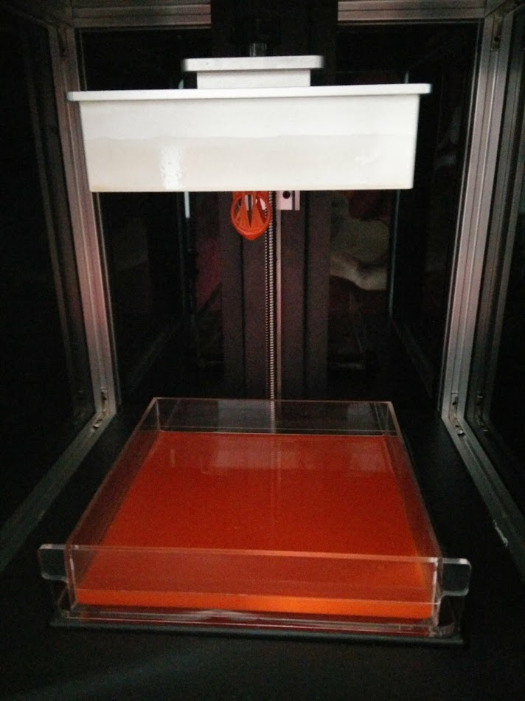

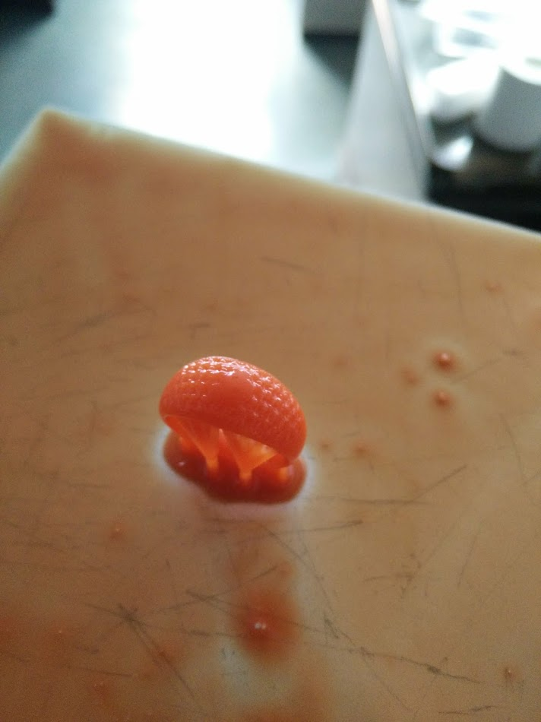

* Washing off

Not only object is not fully cured, there are resins sticking on the object. We must first removed those resins by use ethanol.

Have 2 containers, one filled with ethanol (not 100% filled, 30%-50% depending on the depth). And one filled with water. Dip the object in ethanol first and quickly shake for 30 seconds before put the object into the water and shake for 10 seconds. Repeat this at least twice. More if there are still resin on the object. There is no need to submerge object in the ehanol for extended time (>2 minutes).

* Final Curing

Please the object under direct sunlight or under UV light fixture. Sunlight is slower but free, and can be speed up by submerge the object in water. UV light is quicker but need special equipment.

Formlabs has a nice guide that applies to Moai:

<https://formlabs.com/support/finishing/post-print-steps/>

After curing, you could use UV blocker like this: <http://www.krylon.com/products/uvresistant-clear-coating/>

To prevent further over-curing that may lead to brittleness.

**Cleaning**

This is definitely the least fun part of the process. You do not need to clean the vat or the system all the time but you may need to, especially after a failed print.

To prevent failed prints (and sometimes successful prints) leaving small half-cured objects in vat that could affect future prints, it is best to inspect when there is a failed print. You can inspect by holding the vat up under artificial lights (not UV light).

**DO NOT REMOVE VAT BEFORE REMOVING THe PLATFORM**

To remove free floating tiny objects in the vat, you can use a flat head tweezer. If there is too many tiny objects in the vat, you could filter out them using a coffee filter

Here is another good write up from Formlabs that apply to laser SLA printer:

<https://formlabs.com/support/printers/form-2/keeping-resin-tank-clean/>